SQL Assignment !

1.Import SQL Script “World db” and then execute the script.

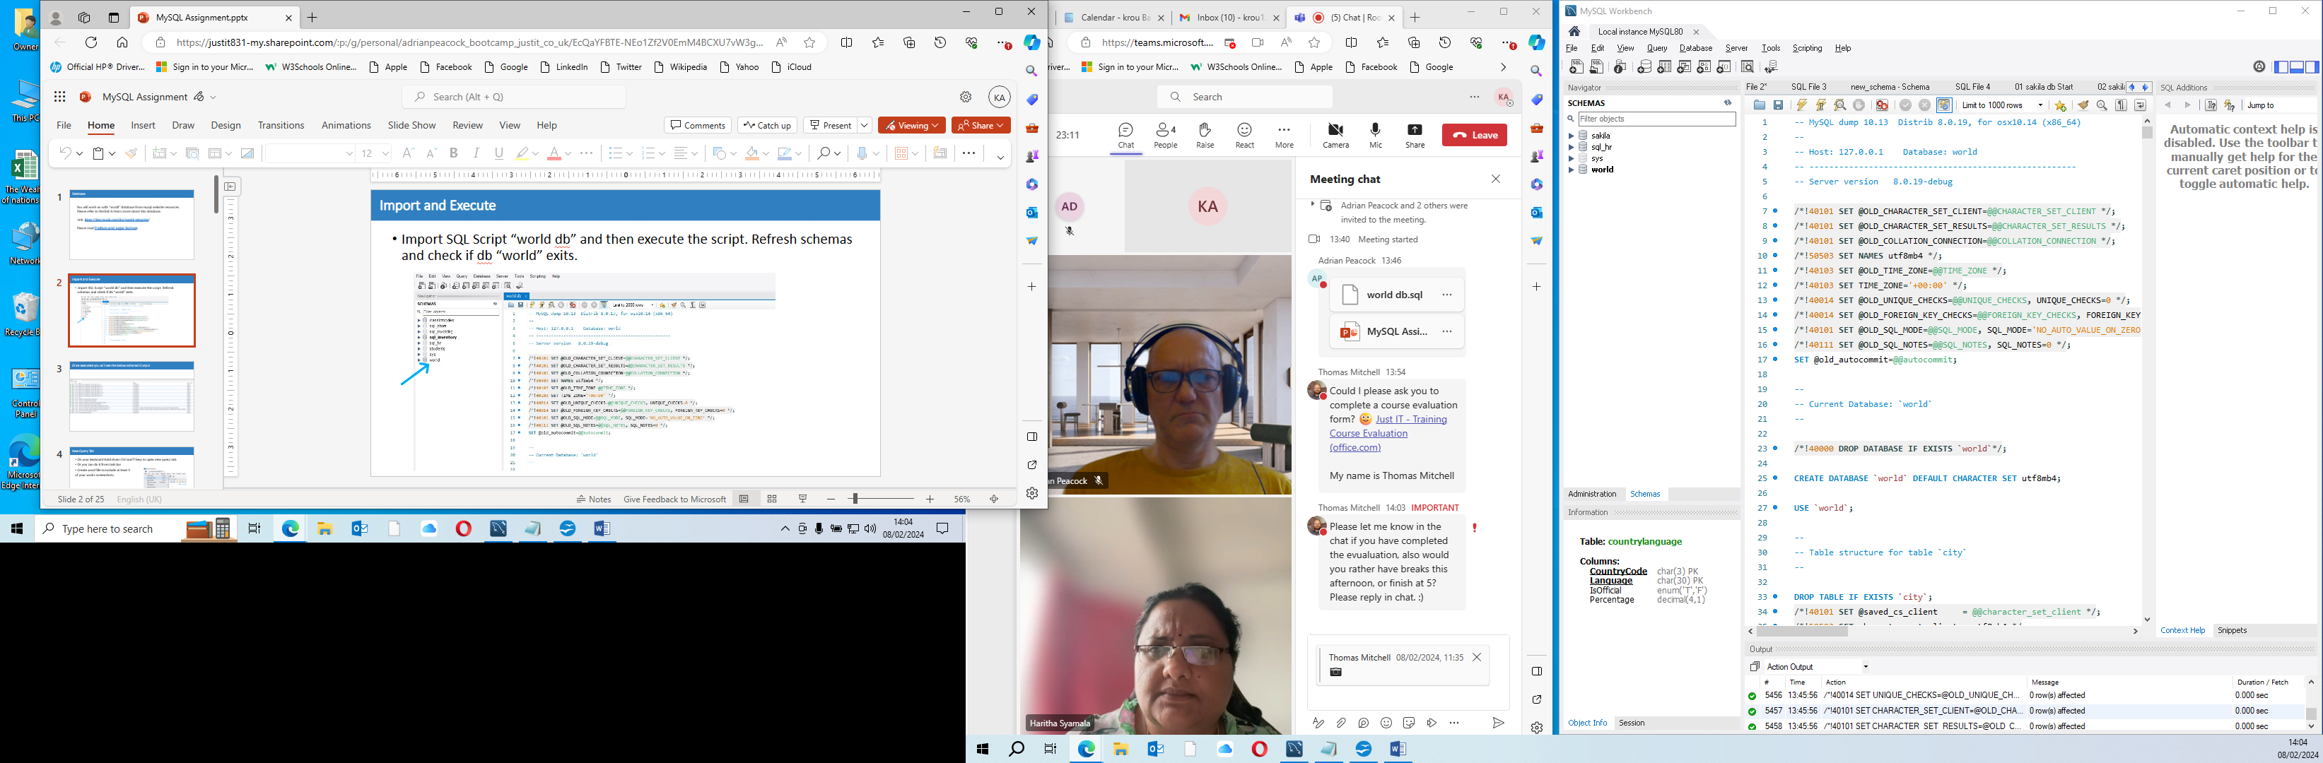

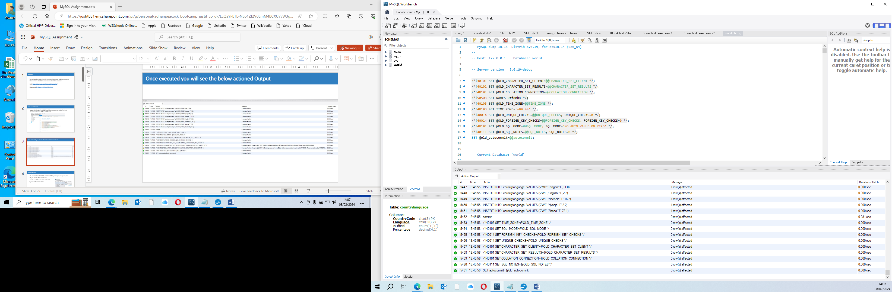

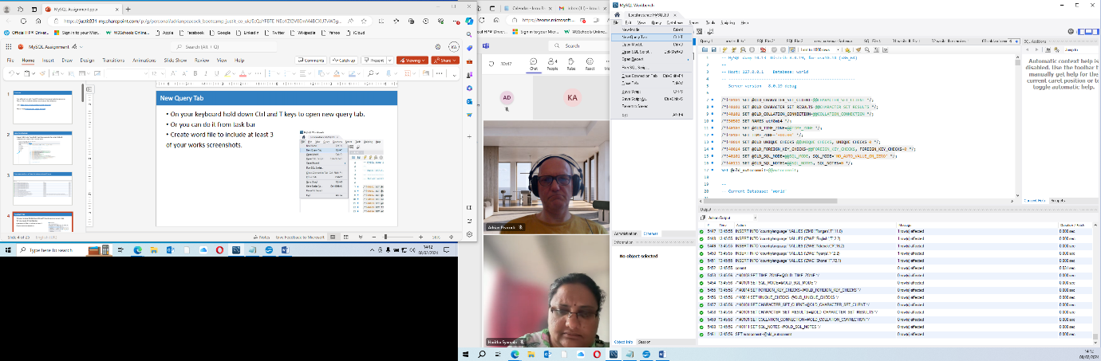New Query tab.

Use # key to comment your tasks.

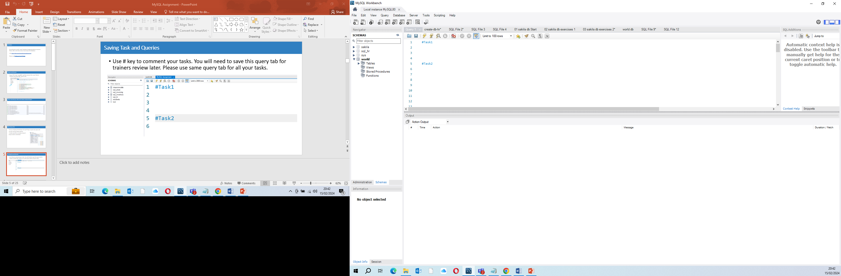

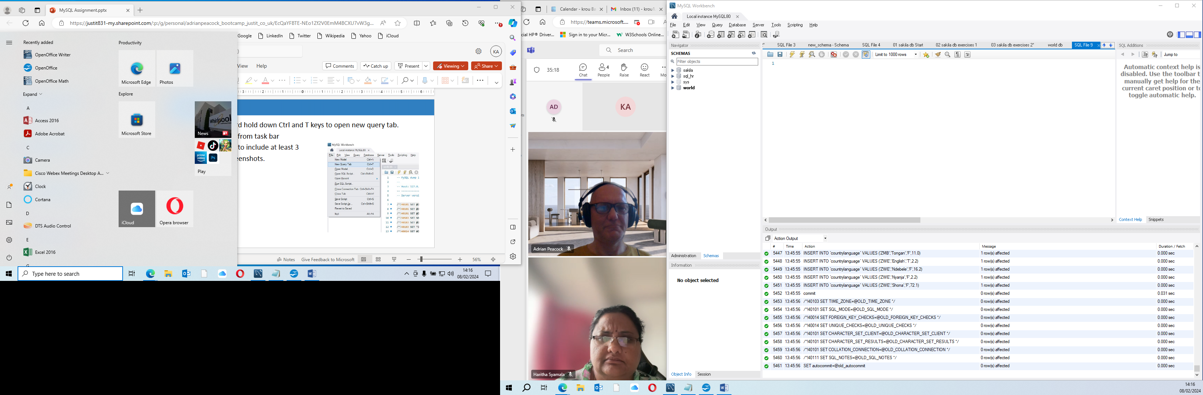

Task 1: Using count, to get the number of cities in the USA

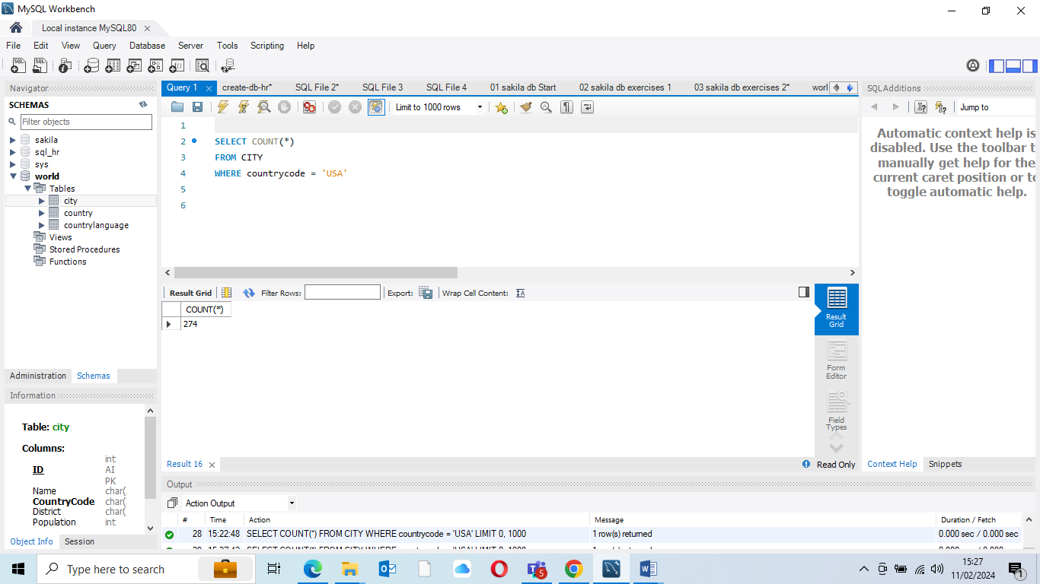

Task 2: Find the population and average life expectancy for people in Argentina (ARG)

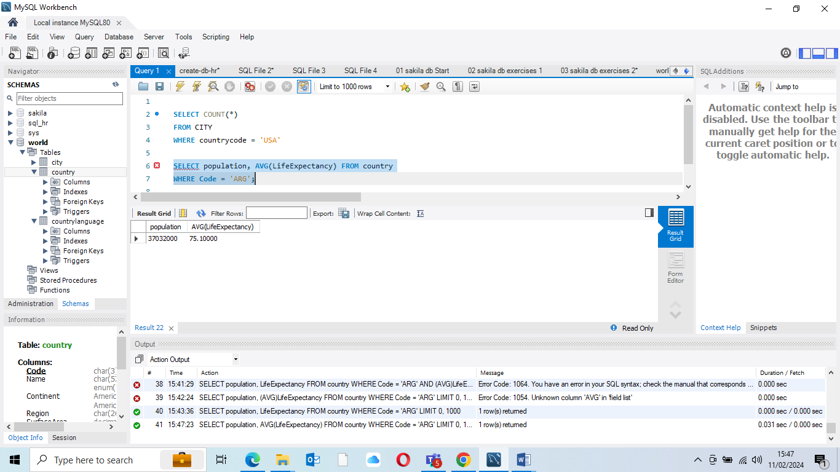

Task 3: using order by, Limit to find out what country has the highest life expectancy

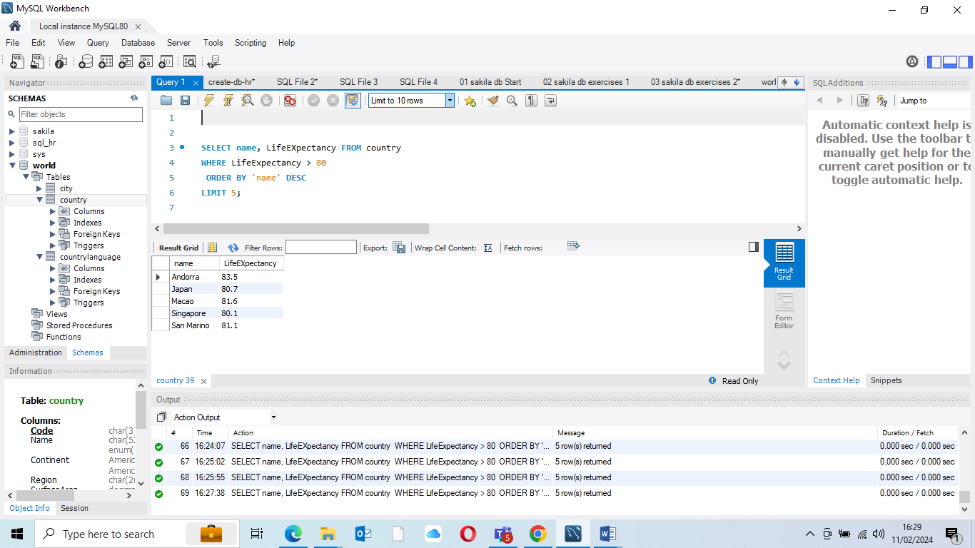

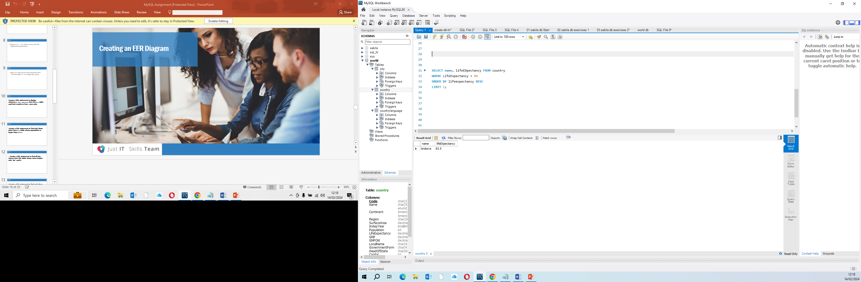

Task 4: Limit not working on my system 25 countries

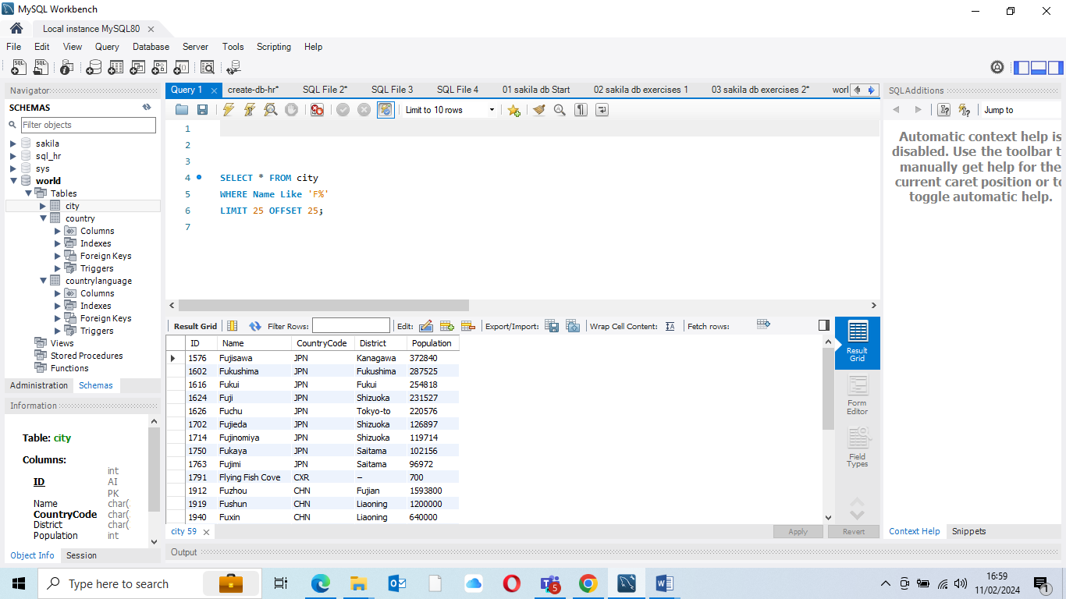

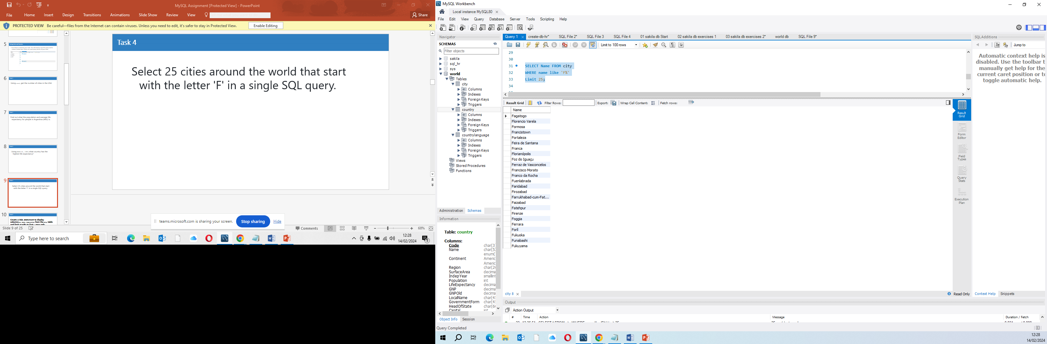

Task 5 create a SQL statement to display columns: ID, Name, Population from city and Limit 10 rows

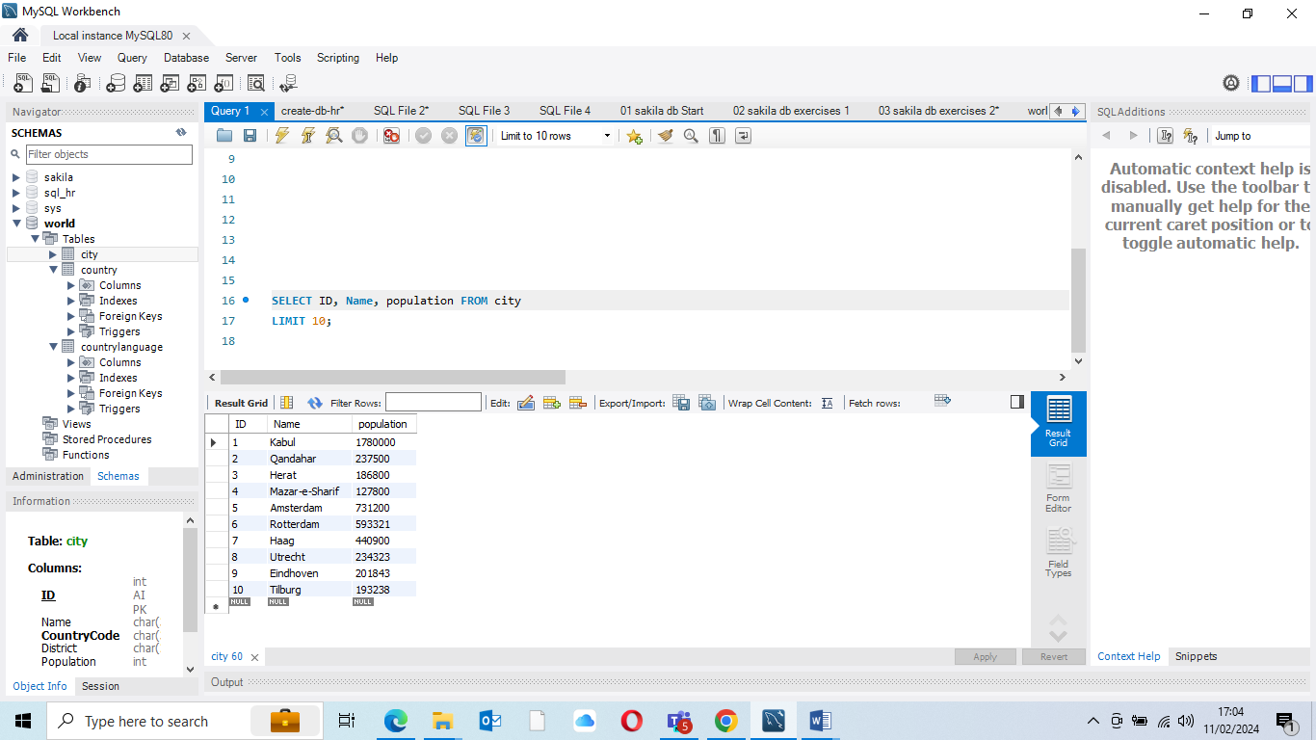

Tasks 6: Population greater than 2000000 from city table

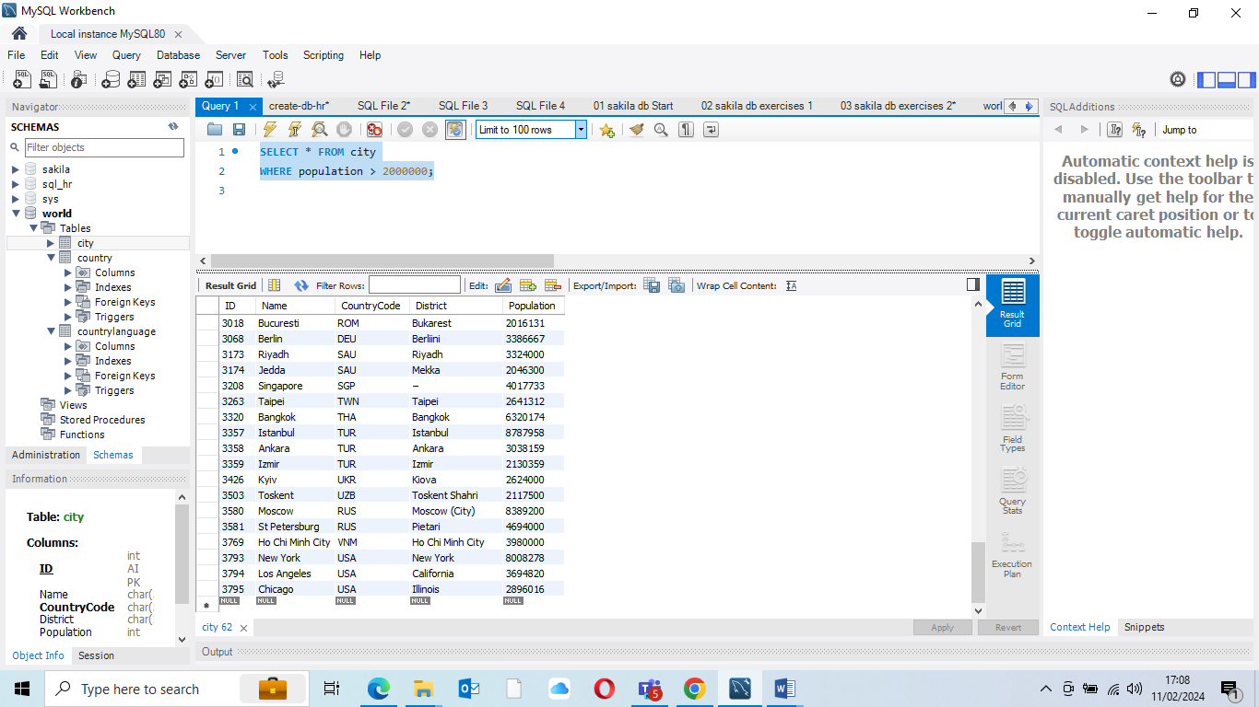

Tasks 7: Create SQL statement to find all City names from city table with ‘Be%’ prefix.

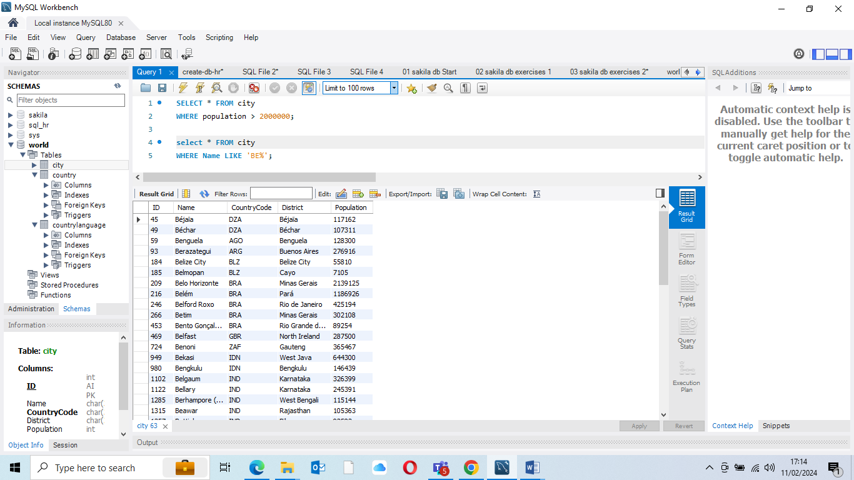

Task 8: Create a SQL statement to find only city whose population is BETWEEN 500000-1000000

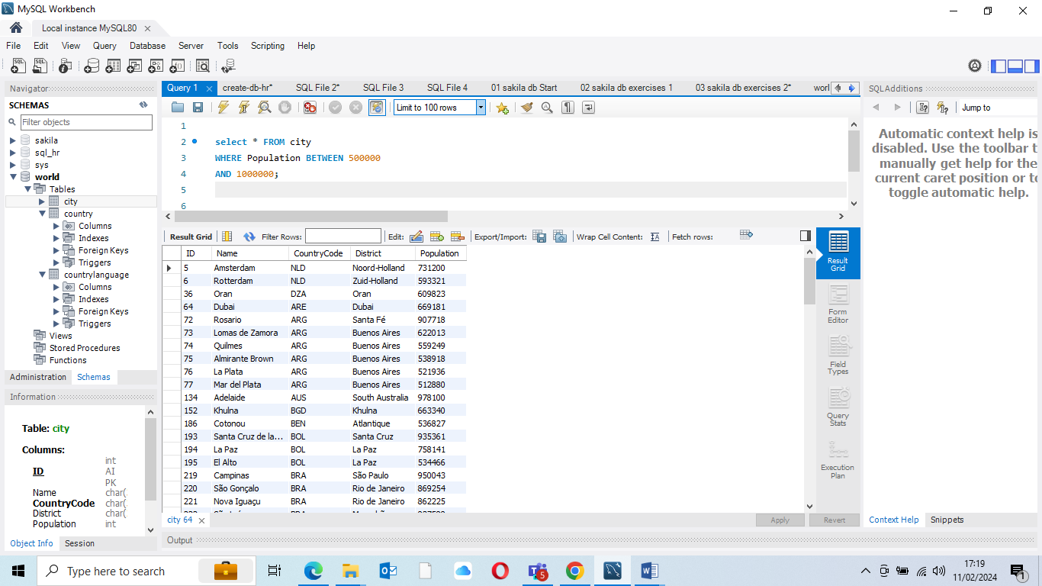

Task 9: Create a SQL statement to find a city with lowest (MIN) population in the city table.

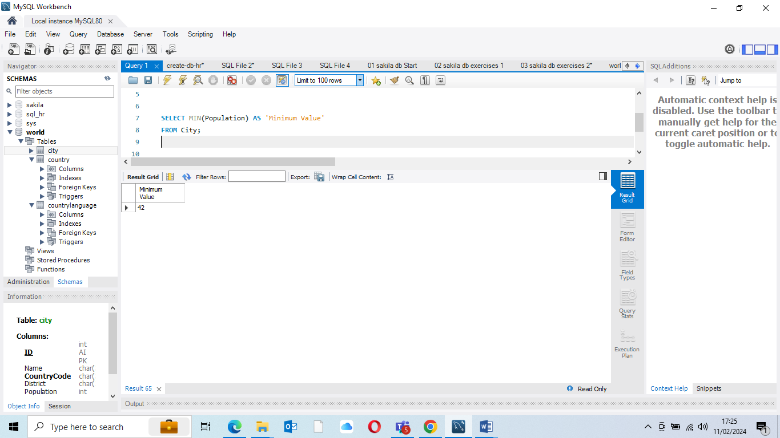

Task 10: Create a SQL statement to find the capital of Spain (ESP)

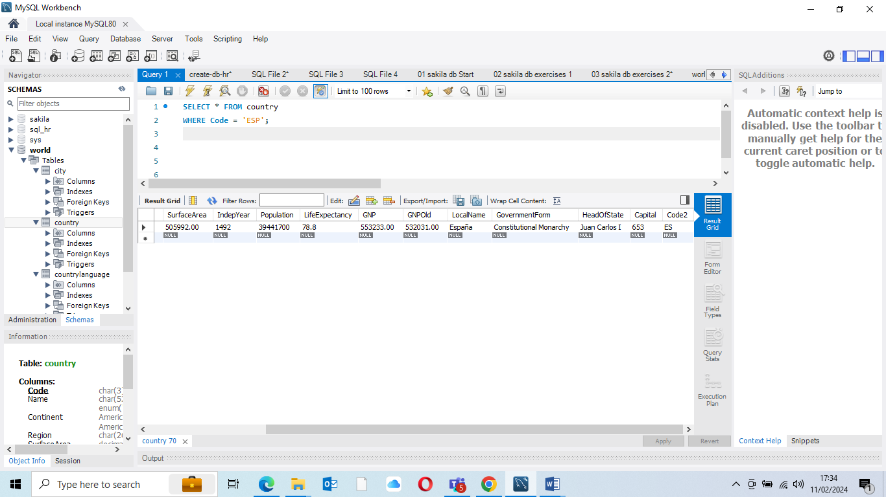

Task 11: Create a SQL statement to list all the languages spoken in the Caribbean region.

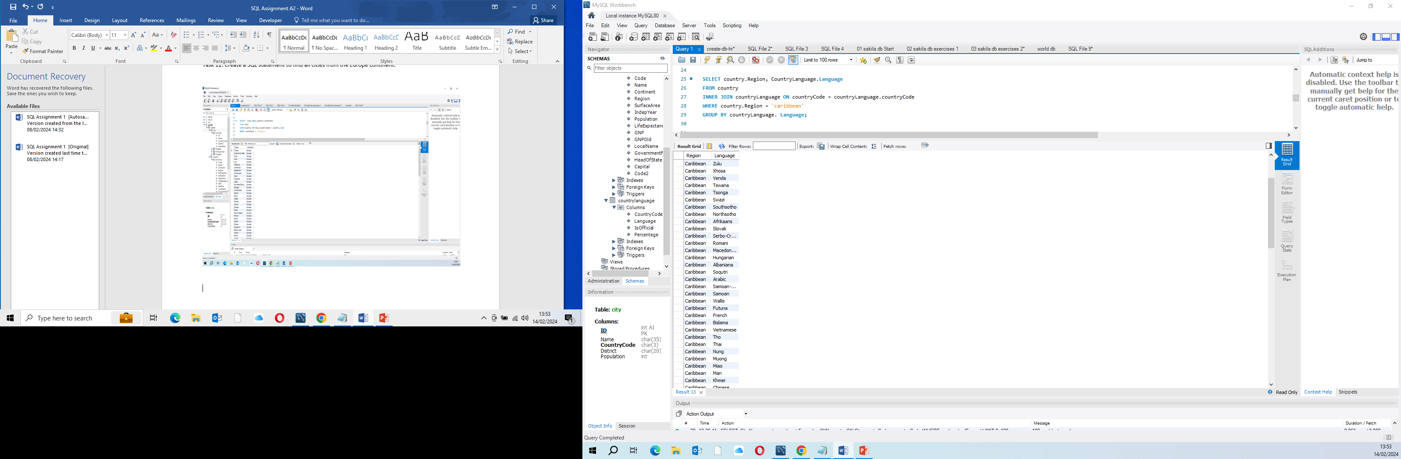

Task 12: Create a SQL statement to find all cities from the Europe continent.

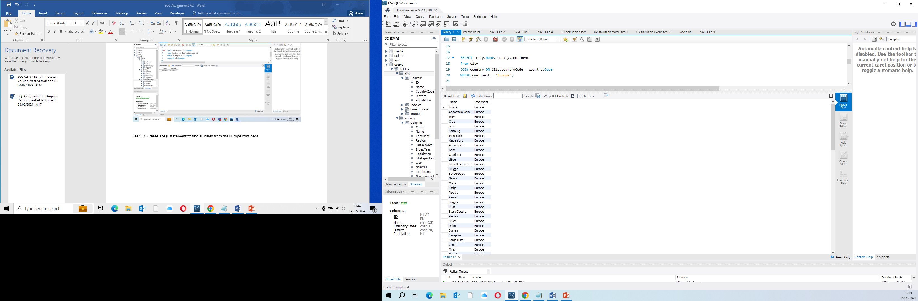

Create an EER Diagram

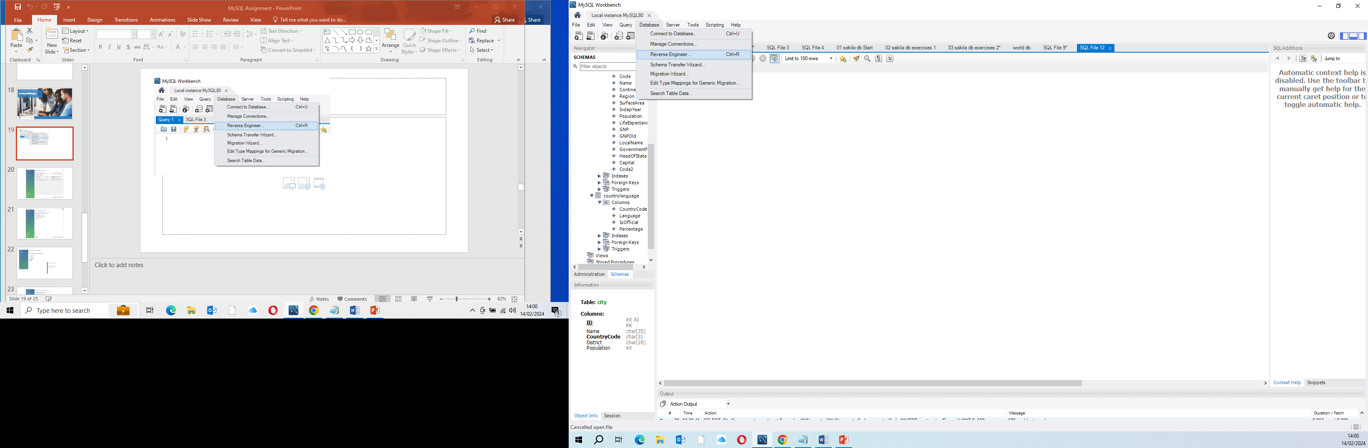

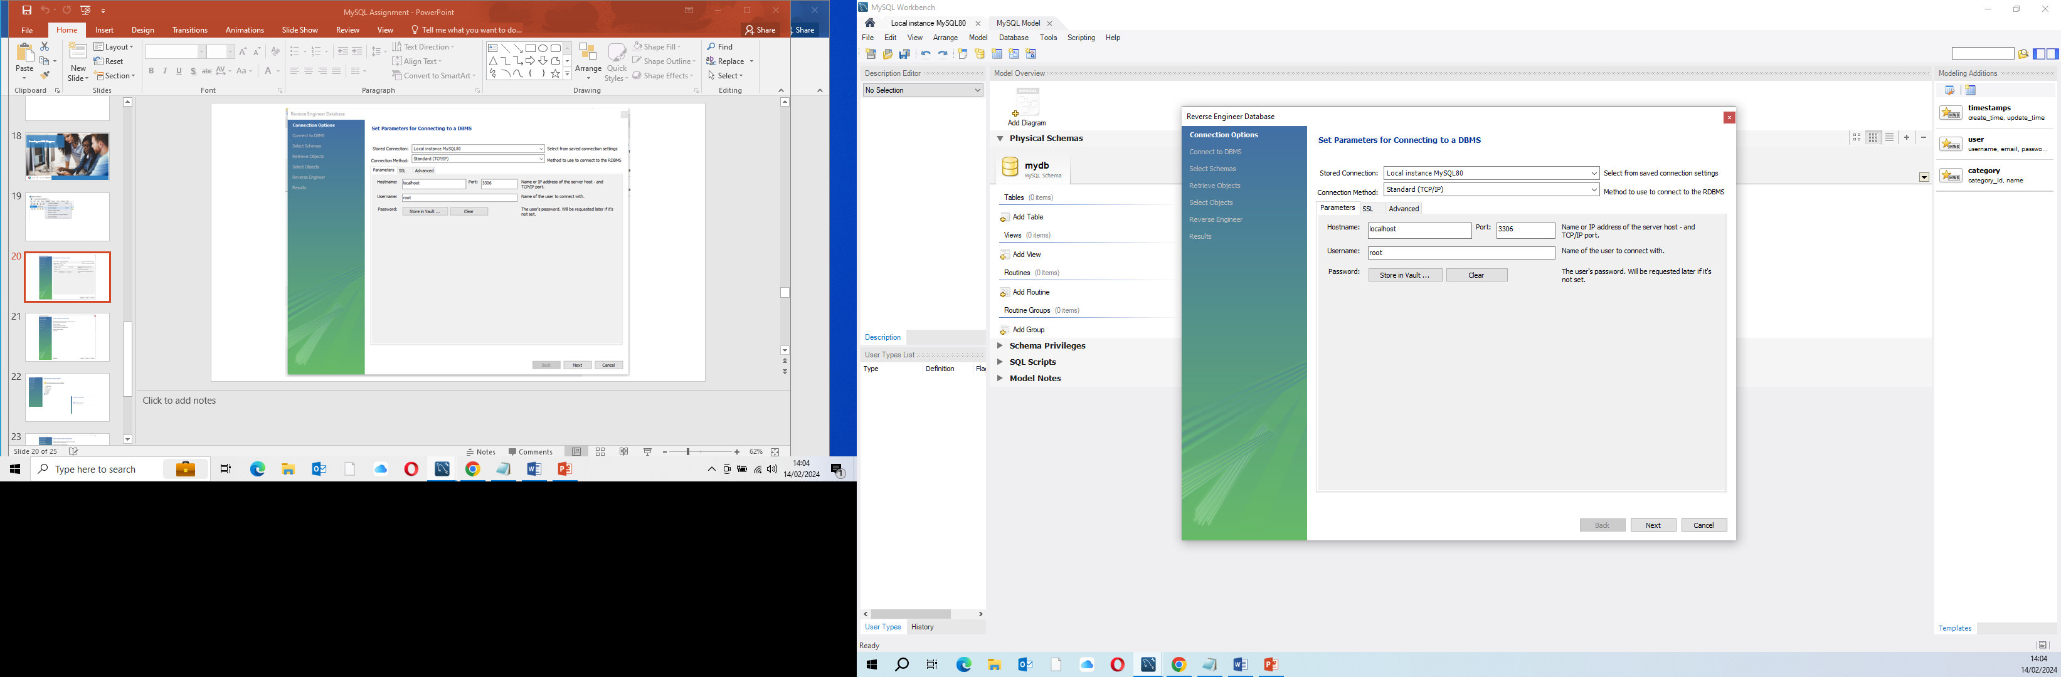

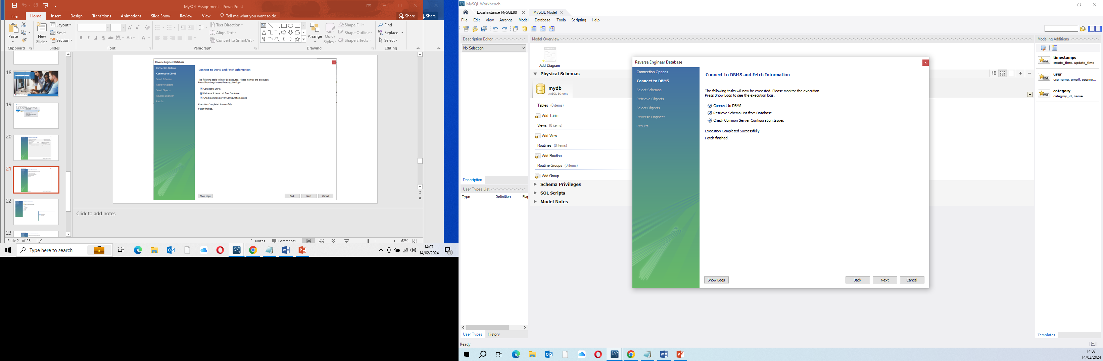

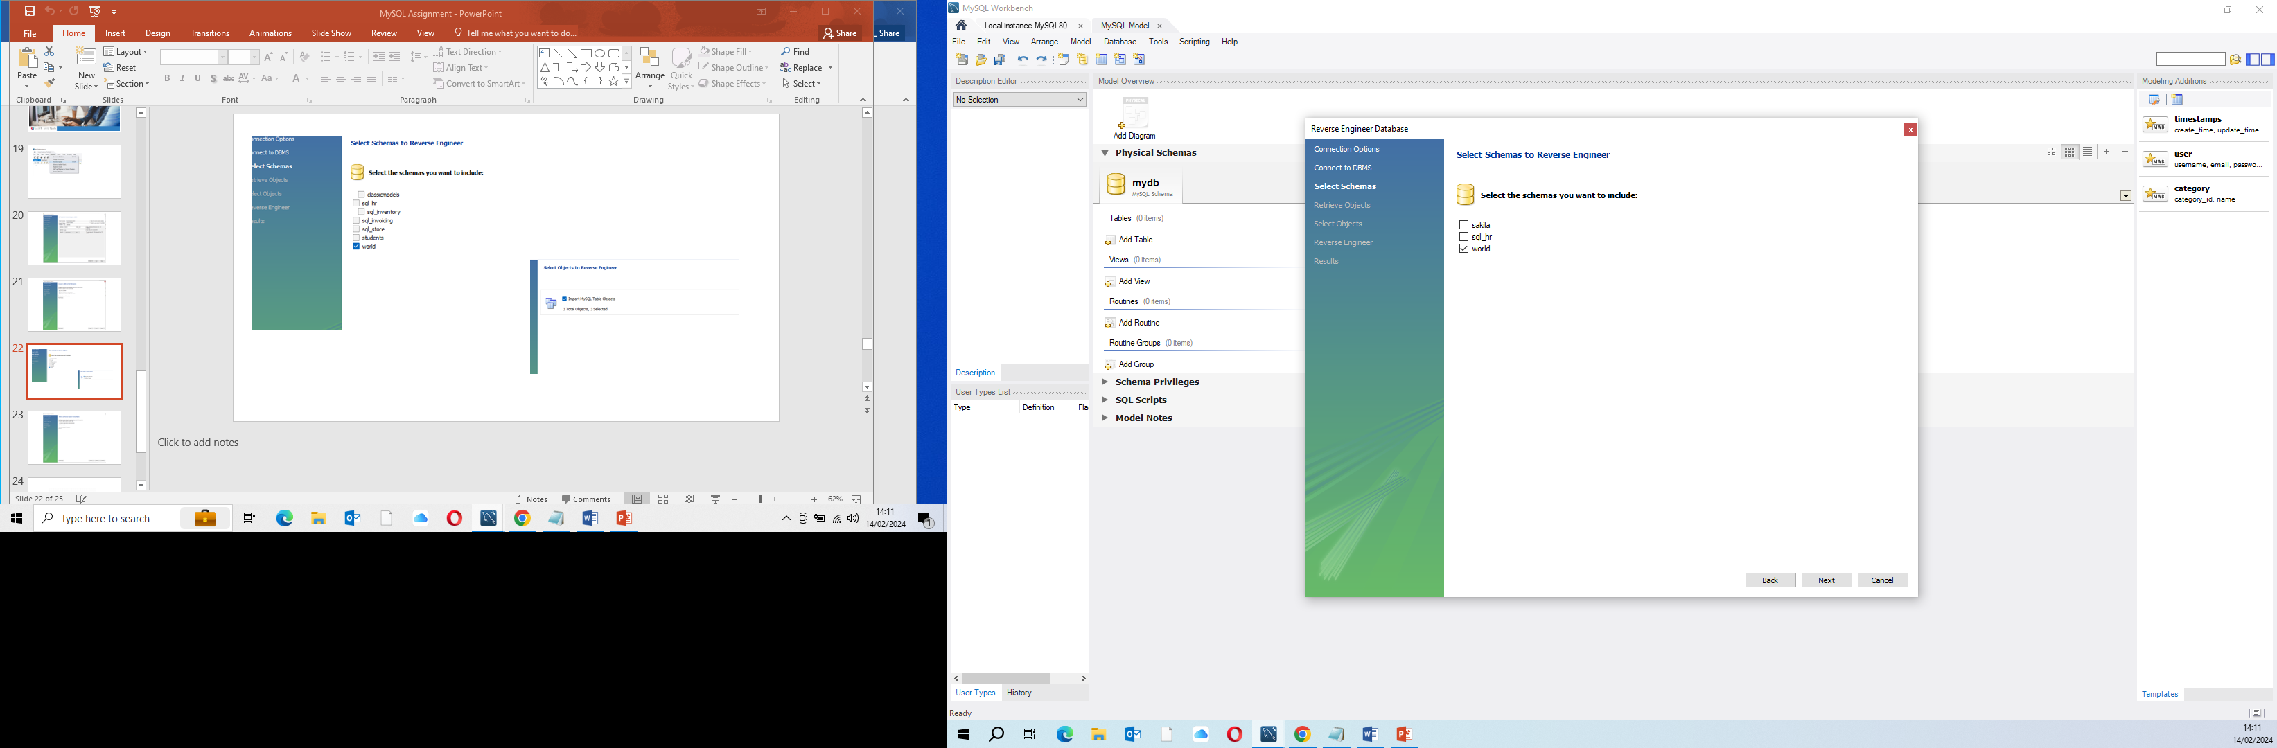

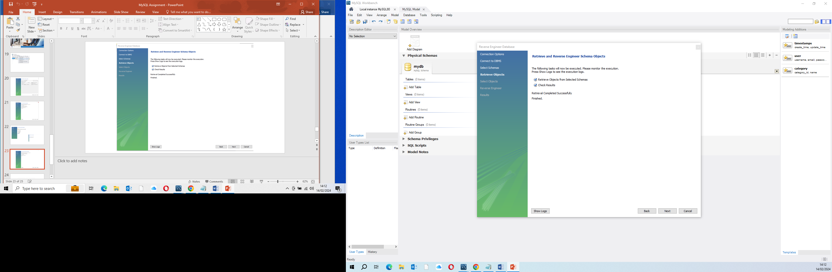

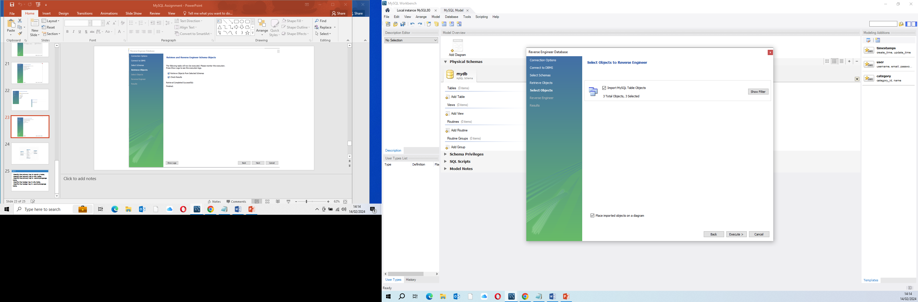

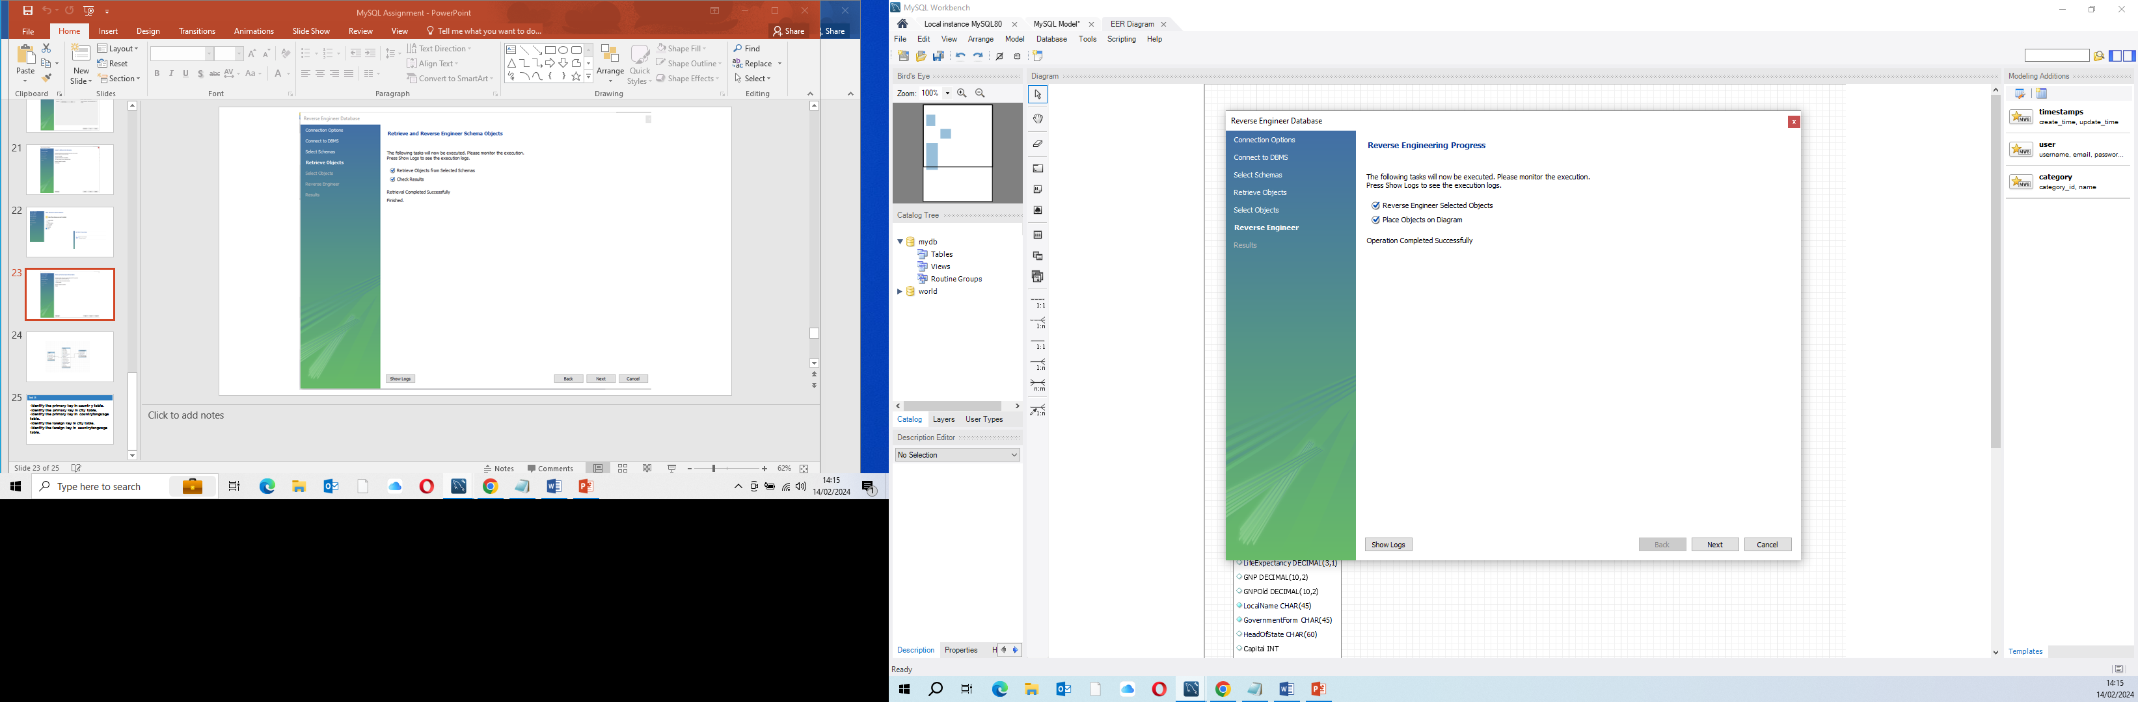

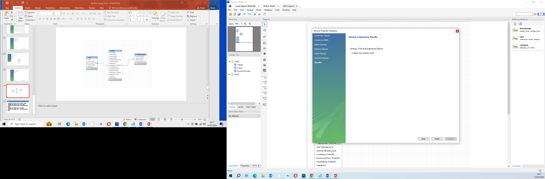

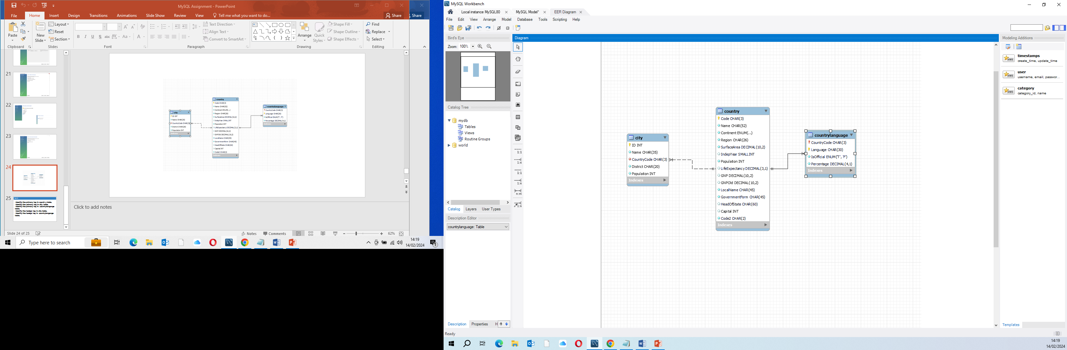

The Primary Key in Country table is: Code CHAR (3)

The primary key in city table: ID INT

The primary key in the countryLanguage is: Language CHAR (30)

The foreign key in city table is: CountryCode CHAR (3)

The foreign key in countryLanguage table is: CountryCode CHAR (3)